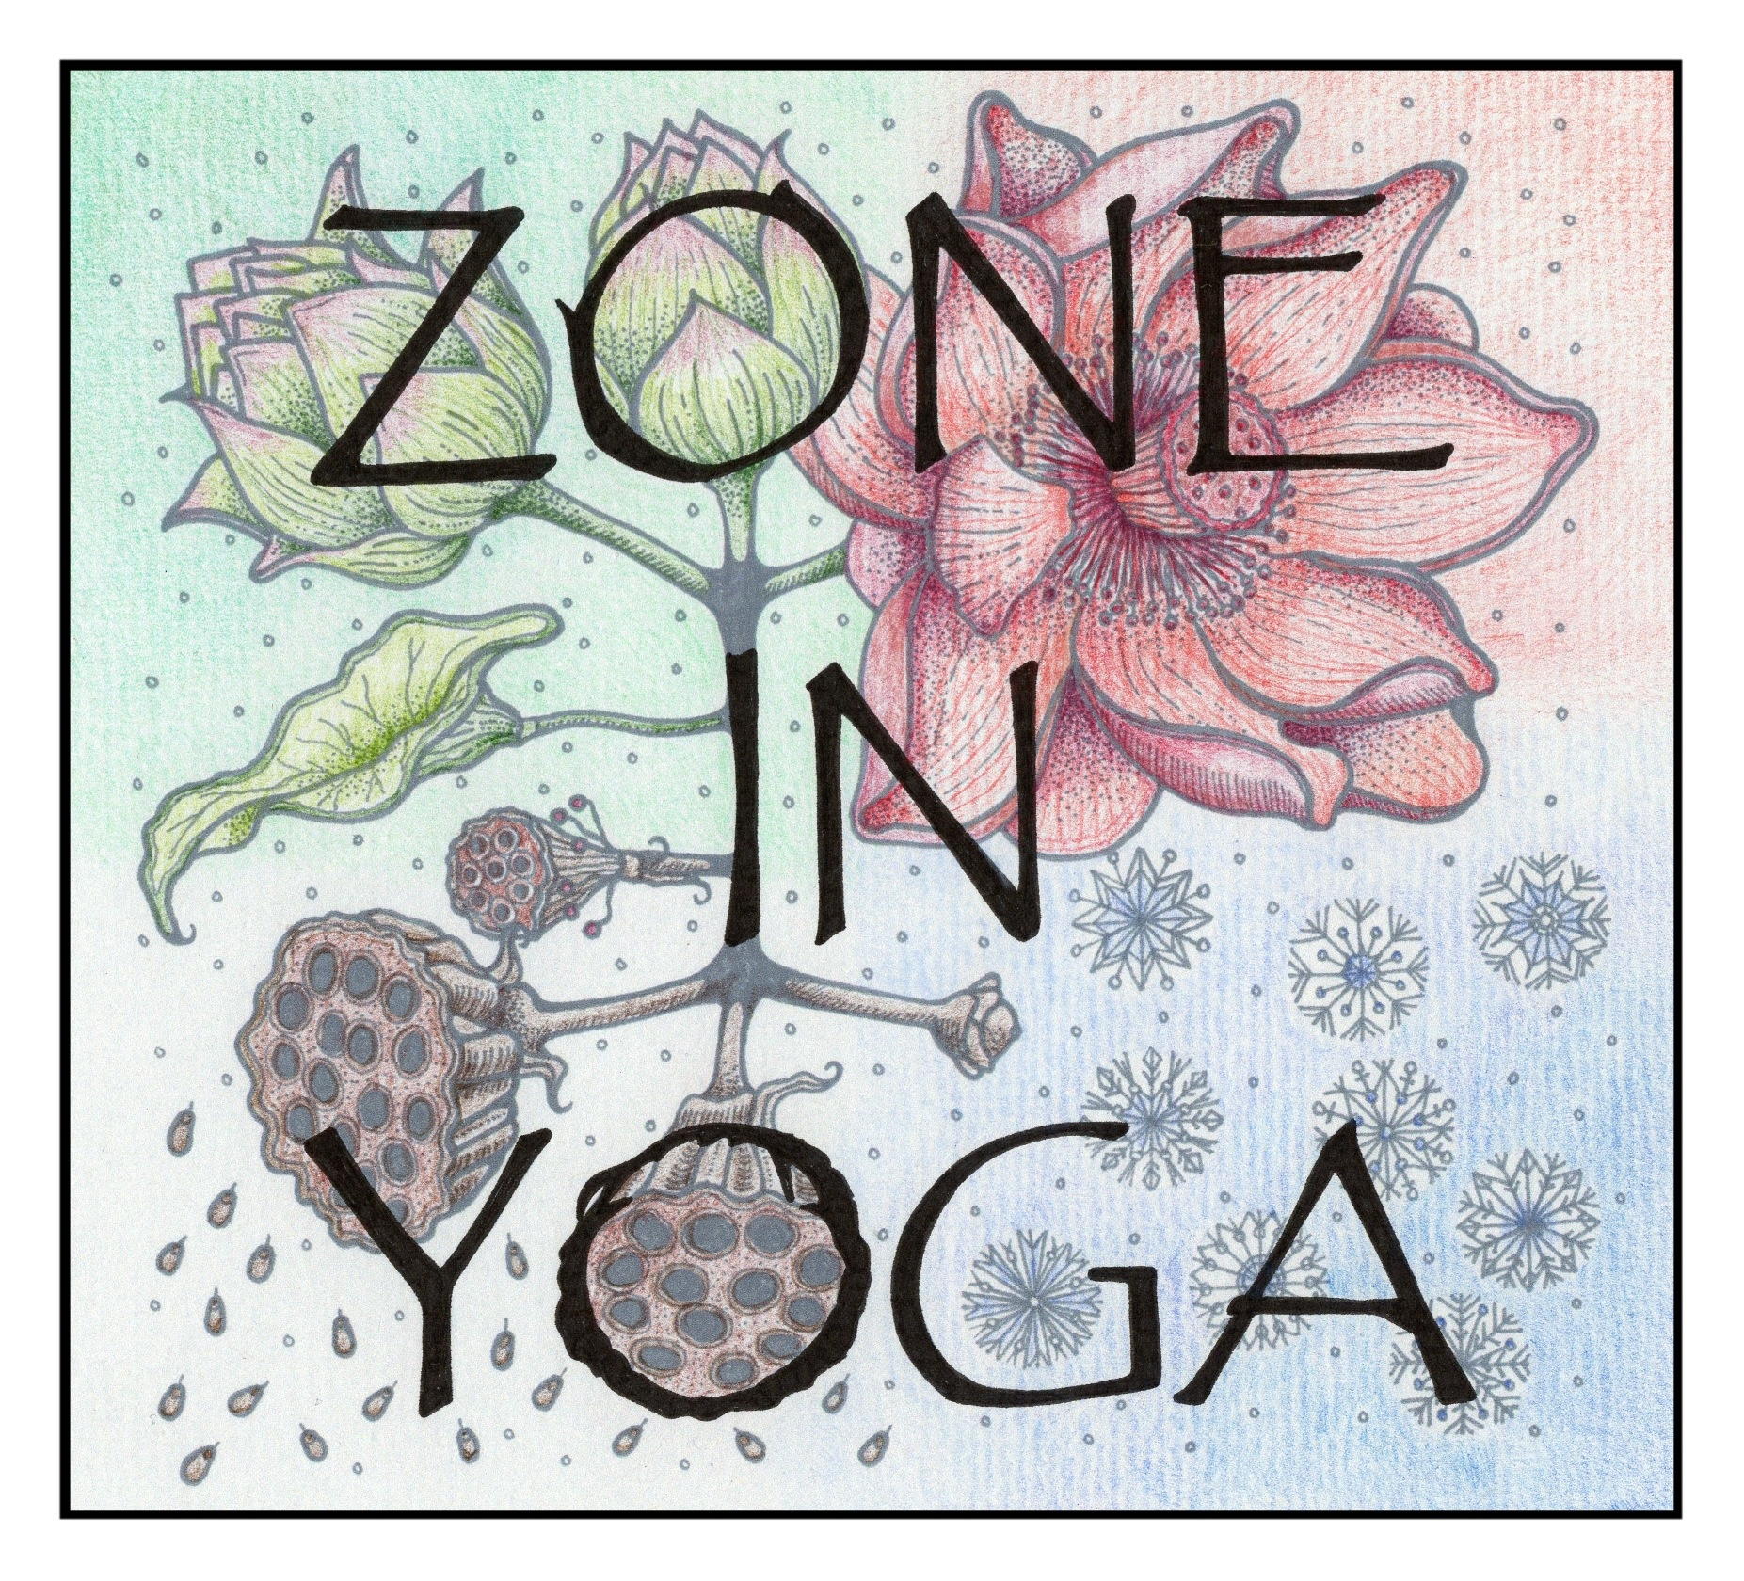

Zone In Yoga - New Client Form / 2021

Name:

Tel No:

DOB:

Email:

Emergency contact name & number:

How did you find out about Zone In Yoga?

Please answer the following questions:

Have you practised yoga before? YES NO

Which style of yoga are you interested in?

What other type of exercise do you participate in?

Do you have High/Low blood pressure? YES NO

Do you suffer from Asthma, Diabetes or Epilepsy? YES NO

Do you suffer from any joint problems? YES NO

Are you taking any medication? YES NO

Have you recently had any surgery / medical procedure? YES NO

Are you pregnant / recently given birth? YES NO

* If you have answered ‘yes’ to any of the above, please give more information below. Any other information you think is important please add below.

Disclaimer:

In person classes during Coronavirus (COVID-19)
If I attend an in person class whilst Coronavirus restrictions and safety measures are in place, I will:
(A) Take care of myself by following the appropriate government guidance on measures such as hand washing and social distancing.
(B) Follow the protocols and safety measures set out by Hannah Juliano for attending in person classes
(C) Not attend any class with Zone In Yoga, should I be displaying any Coronavirus symptoms, have knowingly been in contact with anyone who is symptomatic, received a positive test in the last seven days or be waiting on a Coronavirus test result.
(D) Inform Hannah Juliano should I develop symptoms following attendance at an in person class.

Online and virtual classes
(A) As with our community hall classes, by taking part in any online class, you acknowledge that classes may be physically strenuous, and you voluntarily participate in them with full knowledge that there could be a risk of personal injury.
(B) When practising from home, you accept full responsibility for your space and the health and safety precautions within this space.
(C) You acknowledge that Zone In Yoga accepts no responsibility for any potential injuries as a result of practise outside of the hall space.
(D) Whilst practising online the student is responsible for choosing and taking suitable modifications within their practice and if a student chooses to divert from the general instructions of the class, then they are doing so at their own discretion.
(E) Whilst practising online the student understands that with their camera on, they are visible to the teacher and other attendees who are in the online space. They are not visible to attendees in the physical space.

I would like / not like to be added to the Zone In Yoga database. If you agree then you will receive monthly newsletters and other seasonal emails. You can opt out of these at any time.

By signing below you agree with Zone In Yoga's terms and conditions.

Signed: Date:

